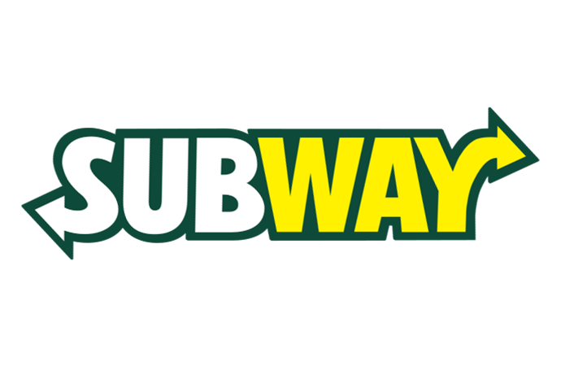



Session: 2021 – 2025

**Submitted by:**

Muhammad Salman 2021-SE-04

Muhammad Farjad 2021-SE-56

**Supervised by:**

Ma’am Zara

Department of Computer Science

**University of Engineering and Technology**

**Lahore Pakistan**.

# Table of context

1. Abstract---------------------------------------------------------------------------- 03
2. Introduction----------------------------------------------------------------------- 03
3. Problem Statement--------------------------------------------------------------- 04
4. Objective-------------------------------------------------------------------------- 05
5. Proposed Methodology --------------------------------------------------------- 05
6. Functional & Non-Functional Requirements -------------------------------- 05
7. Related Work -------------------------------------------------------------------- 10
8. Gant Chart ------------------------------------------------------------------------ 13
9. Wireframes----------------------------------------------------------------------- 14

# ABSTRACTION:

Subway[1] is a fast food chain restauarant whose franchise is all around the world. Subway have become second largest sandwiches ( Subways [2] ) seller in the world.Subway1 has nearly 40,000 restaurants, all independently owned and operated by franchise[ref].

The Objective of Subway1 is to provide variety of sandwiches and nutreintail diet instead of pizza and hamburgers as they cause problems. There main foucs is to provide low calories meals with good taste.The Main goal is to provide customize food that meets the customer taste and needs.

In upcoming years, Subway1 will add further more franchices and variety of nutritional diet for all kinds according to the need of the regular customers. By this Customer can enjoy there taste without tension of any probleme.

# INTRODUCTION:

Subway is a US incorporated organization that operates in the fast-food industry. Mainly concentrating on sea sandwiches, the company expands through the area monopoly strategy. Doctor’s Associate Inc. not only owns the fast-food supply chain, but also operate it.

Subway is one of the first growing single brands across the globe. As at the end of 2014, the organization had an excess of 43,000 different outlets in over 108 operational territories (Convert & Gibson 2015).

Subway provides you the facility of owning a franchise with requirements and paper works. The theme of franchise is same for all around the world the reason for this as they follow the standards like MacDonald’s do that all the faculty member clothing’s themes must be similar, which make a good impact on customer with increase in its reputation.

A Subway website, helps you to own a franchise for your own business and find you nutritional meal instead of traditional fast food .Subway Company is a leading Fast Food chain of stores whose franchise are all around the world . The main office is in North America. Subway Company is classified as Service Sector Organization which offers healthier food instead of pizza and hamburgers as they cause problems likes obesity

Objective is to provide nutritional diet all over the world, where you can also customized meal according to your own need. The main goal is to provide Customized food the meets clients taste and needs.Ther reason is as there are many competetiors in market and customer top’s priority is “Taste & Health “ , so takin this in point of view they decided to add variety along with the nuteritonal chart that help the customer to understand what they are consuming and is it healthy for them. Or Is it the right diet?.

Subway loves his customer that’s why there are trying there best to meet the client’s tastes that lead to the success of both customer trust and restaurant profit.

# PROBLEM STATEMENT:

As Profit increases with increases in sales. So in order to gain more profit we have decreased down the prices of our product to affordable level which lead to a successive amount of sale. This can be illustrated by bellow diagrams.

|  |  |
| --- | --- |
| When the Prices goes down the demand of product increases: Price elasticity of demand (Subway Black Forest Ham) | 1. Income Elasticity for Subway's ProductsIncrease in Demand result into more Income ( profit ) |
| Supply-Demand Curve  That’s how the Equilibrium is maintained and Profit is increase | |

# OBJECTIVE:

Our Objective is to provide the Graphical representation of our meals to customer. Customer can own a Franchise from anywhere in the world with some paperwork’s and fulfilling Requirements. Also u can work with us through contacting us this website.

# PROPOSED METHODOLOGY:

We Use Html 5 to write the structural code of this website. By using CSS we make our website user-friendly and easy to use. We also add references link which help customers to directly go to the desired placed by just click. This task is done with the help of JAVA_SCRIPT.

# FUNCTIONAL & NON FUNCTIONAL REQUIREMENTS:

* Functional requirements:

**Account creation:**

* *Our system shall offer customers to create their own personal accounts where they can create their own avatars for added functionality.*

**Log in page:**

* Our system shall offer customers as well as employees to log in to their respective accounts.

**Set country:**

* Our system shall offer customers and staff members to set their respective countries and locations of deliveries, , for home delivery services
* Our system shall offer staff members to set their respective countries and locations of deliveries, for home delivery services

**Set locations:**

* Our system shall ask customer to type in their nearest subway restaurant so that their deliveries can be sent to their locations quickly.

**Display menu:**

* Our system shall display customer the whole menu containing all food choices available in that particular time.
* Our System shall display the premium deals that are on high peak in that particular week.
* Our System shall display the special foodies from that subway’s particular branch.

**Catering services:**

* Our system shall provide separate functionality for catering menu.
* Our system shall provide catering FAQs.
* Our system shall provide catering planning.

**Contact and about us:**

* This system shall provide options for contacting the managers regarding the ordering problems.
* This system shall provide options for contacting the customer care regarding the ordering problems.
* This system shall provide options for contacting the customer care regarding the feedback.
* This system shall provide the links in order to reach us at different platforms

**Jobs:**

* This system shall provide job info so that new employees shall be hired.
* This system shall provide options for owning a franchise by an individual for boosting their branch.

**Special deals:**

* This system shall show the latest special deals from the branch and their pics as well.

**Customization:**

* This system shall offer customers to customize their order according to their taste, and use toppings according to their chills.

**Extras:**

* This system shall provide an extra menu for the breads and veggies.
* Non-Functional requirements :

**Performance:**

* This system must be response each functionality within 1-3 seconds.

**Response:**

* This system must response in less than10 minutes by enhancing our staffs replying strategies

**Throughput:**

* This system must have low throughput by ensuring that our network bandwidth is not high.

**Scalability:**

* **T**his system must be scalable i.e. in case of added functionality our system must not be redesigned by ensuring high future scalability techniques.

**Capacity:**

* This system must hold at least 1500 customer orders at a time by ensuring that our system will provide them with 150 staff members at a time.

**Availability:**

* Our system must be available 24/7 a week and 365 days an year by using uninterruptible power supply (UPS) services.

**Reliability:**

* Our system must be reliable i.e. it must do what it is to do, it doesn’t display an interface of a staff a customer or vice versa.

**Recoverability:**

* If there is an error it must identify that error and display it to the related staff members in order that they recover it.

**Maintainability:**

* This system must have maintaining bodies whom the responsibility of maintaining the system for errors is loaded. Because maintenance takes 79% of the system’s time it is an important non-functional requirement.

**Serviceability:**

* This system must display deals in Graphical user interface so that customer’s interaction must be on high peak.

**Security:**

* This system must be secured from hackers disrupting the system, and must sign in to proper accounts.

**Regulatory:**

* This system must follow the rules and regulations described by the particular country’s government or regulatory bodies.

**Manageability:**

* This must provide the coordinator options and functionalities due to which the system is easily managed.

**Usability:**

* This system must be easy to work with and the customers must not have any difficulty while using our system, also this system must have no ambiguity, or must not use colors that are not visible for color blinds.

**Interoperability:**

* Our system must be self-explained i.e. it must show for what purpose this system is used and what are its outcomes.

**Data integrity:**

* This system must maintain a permanent record for orders so that the customer points are maintained and must maintain consistency constraints of the data.

# REALATED WORK:

* **KFC :**

KFC is the second largest fast food chain brand,which is mater in fried chicken . KFC provides the best crispy freid chicken and zinger burgers that will leave your mouth watering for more.

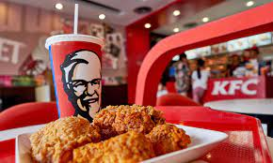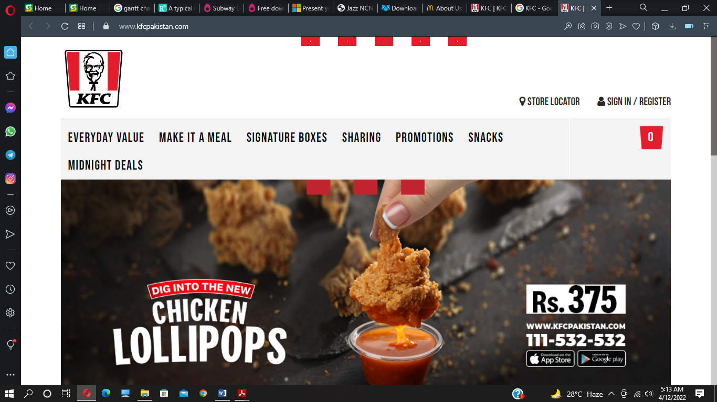

* **MacDonald’s:**

At first it was just a small shop in 1954 , but now it has become the world’s First largest fast food chain brand, it is famous due to its hamburgers .The taste of there hamburgers are recorded to be on the top of taste list , according to cutomer’s feedback

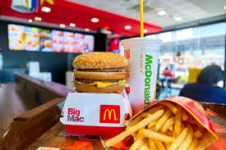

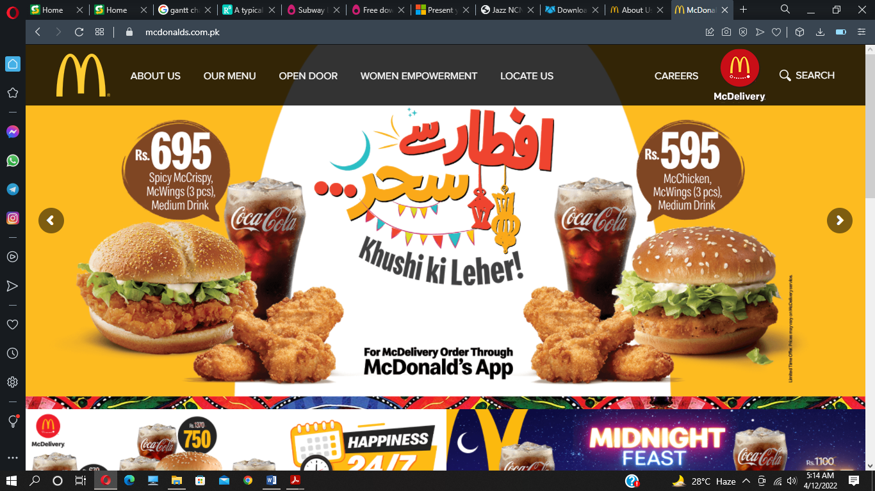

* **STAR BUCKS :**

Star bucks is an American multinational chain of coffe house. But unfortunately there is no branches of STAR BUCKS in Pakistan . Although it is most probably famous due to its coffe with it round table logic.

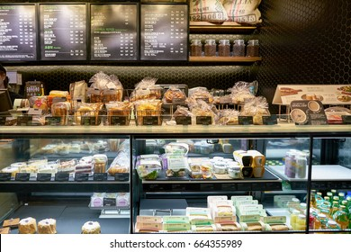

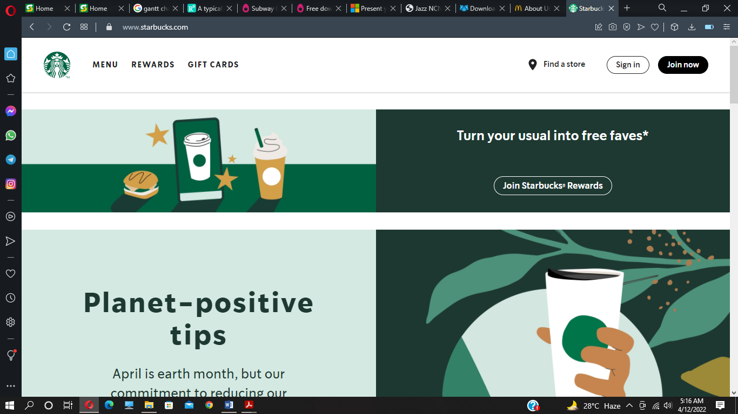

# WIREFRAMES :

HOME :

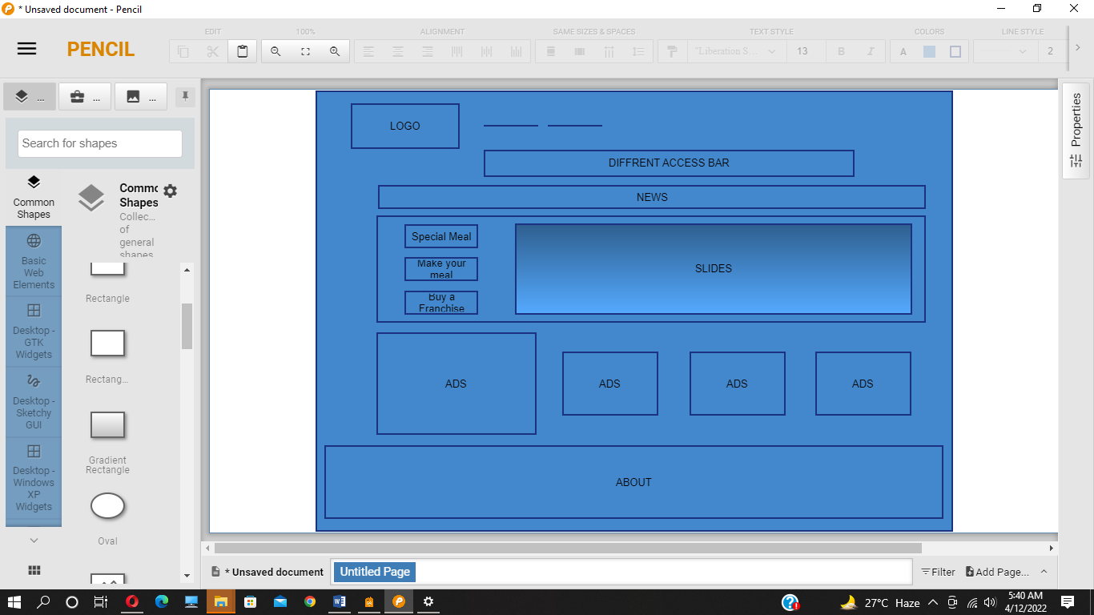

# GANT CHART:

|  |  |  |  |  |
| --- | --- | --- | --- | --- |
| **Steps:** | **First**  **Week:**  (11-20/ Mar /2022) | **Second**  **Week:**  (20-27 /Mar / 2022) | **Third**  **Week:**  (27 Mar-05 Apr / 2022) | **Fourth**  **Week:**  (05-11 /Apr / 2022) |
| **Abstract:** |  |  |  |  |
| **Introduction:** |  |  |  |  |
| **Objectives:** |  |  |  |  |
| **Related**  **Works:** |  |  |  |  |
| **Problem Statements:** |  |  |  |  |
| **Functional**  **Requirements:** |  |  |  |  |
| **Non-Functional**  **Requirements:** |  |  |  |  |

1. [www.subway.com](http://www.subway.com)
2. Kind of sandwiches that u can customize according to your needs